Poem Brochure

This project has two parts: first you must write the poem, then you must create a small brochure about the poem you chose. The instructions are below. All submissions must be submitted electronically to be accepted. The preference is Canvas, but if you cannot access canvas, type both parts of the project and share on Google Docs to shelleah1.jackson@cms.k12.nc.us.

Go through the attachment titled “Poem Styles”. Read through the different types of poems that exist. After looking through the options, pick one you’d like to write. Then complete Part 1 & Part 2.

Part 1
Below, write your poem using the format you've chosen. You must include the following in your submission:

1. Your name
2. The type of poem it is
3. The name of your poem
4. Type the poem

Please note: If you are doing a Shape Poem, when you type it, it must be in the shape you chose.

Part 2
Now that you've finished your poem, you will make a brochure/information pamphlet about the poem you've selected.
You can format the pamphlet however you'd like, however there are some elements that must be included to receive full-credit.

1. The name of the type of poetry you selected
(in large font or Word Art)

2. Where did this form of poetry come from? Who invented it?
Use information from the internet to answer this question. Any information that you find to answer this question must be cited. Any information gotten from another website without the proper citations will result in a 0 on this project.

3. What are the rules for this poem?
In other words, how does someone make a poem like this? This part should be in direction format. For example, you might say: "In order to make a Shape Poem, first someone should..."

4. Put in your example that you just submitted as a demonstration.

This should be completed using full sentences and proper grammar.
______________________________________________________

Example

Jax Poetry!
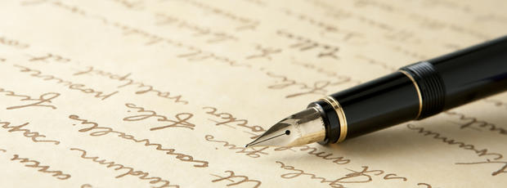
Jax poetry is a form of poetry that was invented in 2016. It was created as a project to help students to understand that there are different formats of poetry and writing, and to give them practice with one (msjax9ela.weebly.com).

The rules of this poetry are as follows:
- It must be all about students
- It must communicate a goal
- It must have at least 4 lines
- It does not have to rhyme but it can!

For an example of Jax Poetry, please look below.

A joyous time is 9 ELA!
We've danced, and sang, and learn all the way!
The goal is for students to be internationally bound,
To make it to graduation intelligent and sound!
There isn't a thing our teach' wouldn't do
To ensure we achieve our goals through and through!
- By Ms. Jax

