Name _____Answer Key________________
Date ________________________________
Quiz #1
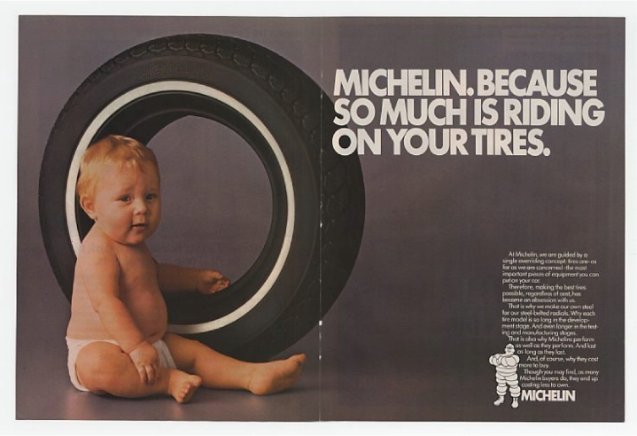
- Which kind of rhetoric device is most strongly used in the advertisement above?
  - Ethos
  - Pathos
  - Logos
  - None of the above

- When a piece of literature appeals to your mind and explains things to you logically, it is using…
  - Ethos
  - Pathos
  - Logos
  - None of the above

- Read the following list. Circle the types of violence we have discussed in class.
  - Verbal/Emotional
  - Serial
  - Neglect
  - Physical
  - Hostile
  - Institutional
  - Sexual

- Pick the answer that best completes the sentence. “___________ is the author’s attitude toward the topic that they’re writing about, however the ____________ is how the reader feels during or after reading a text.”
  - Mood; tone
  - Attitude; mood
  - Bias; feelings
  - Tone; mood

- In the book Persepolis we’ve been reading, what does Marjane want to be when she grows up?
____A prophet__________________________________________________
- In Chapter 3 of Persepolis, Marjane’s dad tells her that her grandpa was a what?
____A prince_______________________________________________________

- In Chapter 2, Marjane’s father is telling her mother about something that had happened at the cinema. Explain what happened and how the public reacted. In your answer, include the following words: police, rescue, attack, and Shah.

At the theater, it either caught on fire or it was set on fire. There were people still locked inside that were trapped, however when the people on the outside tried to rescue them, they were attacked by the police. The Shah claimed that it was an attack from the religious fanatics, but the people of Iran believed it was the Shah’s doing. .

- Explain what diction is, in your own words.
The author’s word choice.

- What is an anecdote?

An amusing non-fiction short-story about an event. Used to prove a point.

- In your own words, what was the author’s purpose for writing Persepolis?

She wanted to demonstrate that she, a Muslim woman from Iran, had a childhood just like everyone else. She also wanted to portray that not all Muslims are extremists/terrorists/fanatics, etc.

